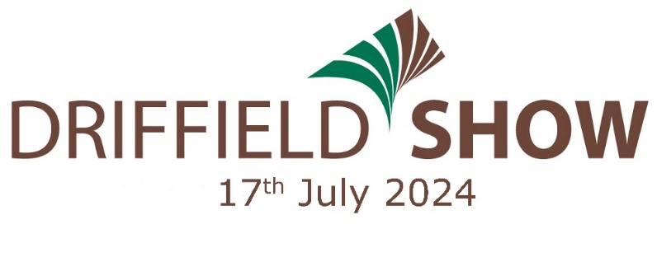

Application for Mobile Catering Space

Company Name
Contact Name
Address
Post Code |  |  | Telephone No
Mobile No
Email
Web Address
Council who the unit is registered with:
TRADE STAND – OUTSIDE SPACE |  |  |  | Frontage Required |  | Depth Requested
Catering Unit |  | £600 + vat
Tea & Coffee Unit |  | £500 + vat
EXTRA REQUIREMENTS Please indicate the quantity required
Each catering unit will be allocated two complimentary tickets
Additional Advance Tickets can be ordered here - £18.00
Your business/organisation will be featured online, throughout the year, listing your contact details at www.driffieldshowground.co.uk for the general public to see. |  |  |  |  | £30 +vat |  | Please  tick if NOT required
Description of your business (25 words maximum) for inclusion in the Show Programme.

- If you require an electricity supply please return the relevant order form to events@tsvevents.co.uk who will invoice you directly. Further electricity orders forms can be downloaded from www.driffieldshowground.co.uk.

- Please read the attached Terms and Conditions booklet. Completion and return of this form confirms agreement to Terms and Conditions.

PLEASE COMPLETE THE CHECK LIST OVERLEAF AND ENSURE THAT ALL REQUIRED DOCUMENTS ARE RETURNED WITH YOUR COMPLETED APPLICATION FORM

APPLICATION CHECK LIST 2024 | Tick & include
ALL APPLICATIONS MUST BE ACCOMPANIED BY THE FOLLOWING DOCUMENTS:
Copy of last food safety inspection – Hygiene rating given
Public Liability Insurance
Employers Liability Insurance
Gas Safety Certificates
PAT Testing
Risk Assessments
Fire Certificate/Fire Risk Assessment
Food/Hygiene Training Certificates
Food Hygiene Policy/Evidence of Food Management System
Electricity Application Form
Menu and prices
Image of catering unit

SPACE RESERVATION:
In all cases the Chief Executive’s decision will be final.
Exhibiting in previous years does not guarantee a space for future years.
The Society reserves the right to make a supplementary charge for prestigious sites, corner sites, or sites with multiple frontages.
SPONSORSHIP & MARKETING PACKAGES – We have a variety of packages for Driffield Show 2024
please tick the box to register an expression of interest and we will contact you.

In accordance with the Date Protection Act 2018 the information you submit will be published on the Driffield Showground web site, by providing this you are giving the Society permission to make use of your information on the web site and in their publications. The information you have provided will be shared with the Society’s supporting partners and may be used by them for marketing and promotion purposes. If you do not wish your information to be shared please tick this box. Our full privacy policy can be found on our website www.driffieldshowground.co.uk

I hereby apply for Mobile Catering space as stated above and agree to abide by the showground Mobile Catering Terms and Conditions, of which I have read.

Signed Date

This form must be completed, signed and returned to: -
ideally via email to cheryl@driffieldshowground.co.uk
or
Trade Stand Secretary,
Driffield Agricultural Society, The Showground, Driffield Road, Kelleythorpe, Driffield, East Yorkshire, YO25 9FB

IN AID OF

www.driffieldshowground.co.uk

The Showground, Driffield Road, Kelleythorpe, Driffield, East Yorkshire, YO25 9FB
T: 01377 257494 E: office@driffieldshowground.co.uk

MOBILE CATERING

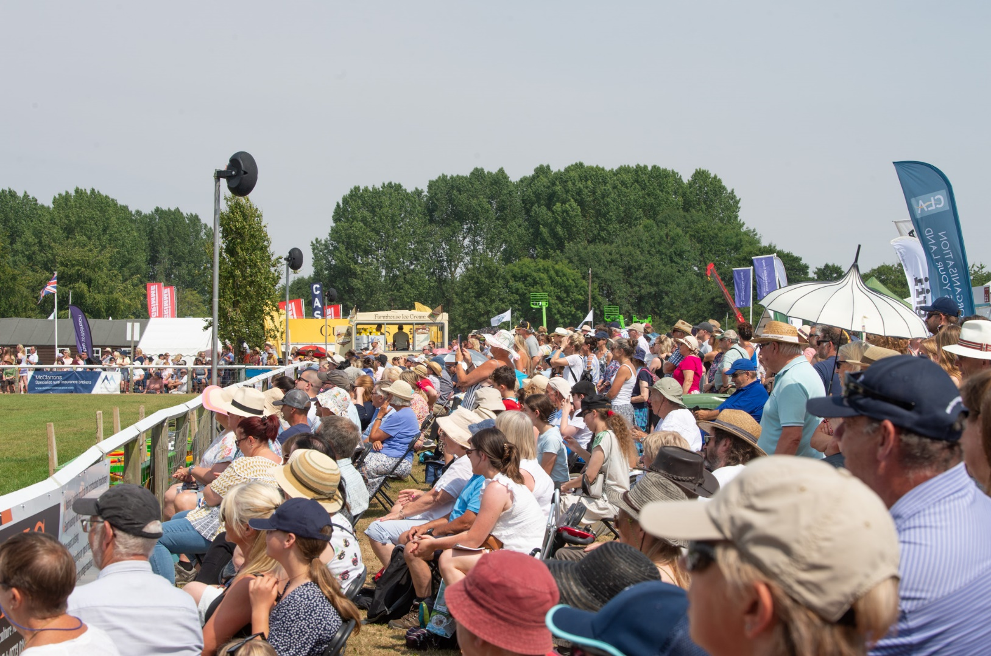

SHOW TERMS & CONDITIONS
FOOD HYGIENE POLICY

- Every person accessing the site on Show day is required to have a valid exhibitor ticket.

- All vehicles entering the site on Show day are required to have a valid vehicle pass. This includes those delivering to stands and those providing catering etc to stands.

Show Set Up

All exhibitors and contractors must sign in on arrival from Friday 12th July and hi viz clothing must be worn during the set up and take down period.

Exhibitors and contractors must arrange for the delivery of all implements, goods, marquees and other requirements before 8.00am on Wednesday 17th July. Roads, car parks and other areas on the Society’s property shall be regarded as highways with special reference to road markings, speed restrictions (5mph on all Society property) and the observations of parking restrictions. Please do not use your hazard lights when moving on Society property.

All vehicles not staying on stands must be off the site by 8.30am, in preparation for the
Show opening at 9.00am.

No vehicles will be allowed to enter the site after 8.30am, delivery by van or otherwise will
not be permitted after that hour.

NO MOTOR VEHICLES will be allowed on the ground until 6pm.
NO LARGE VEHICLES including articulated lorries or low loaders will be permitted onto site before
7pm on each day of the show.

THESE RULES WILL BE STRICTLY ENFORCED

IF VEHICLES ARE MOVED BEFORE 6.00PM THE SOCIETY RESERVE THE RIGHT TO REFUSE THE OFFENDING TRADE STAND SPACE AT ANY FUTURE EVENTS HELD ON THE DRIFIELD SHOWGROUND

Times of Opening and Closing.
All stands must be open by 8.30am on the morning and manned throughout the time the Show is open to the public.
Stands must remain open until 6.00pm.
- Application for Mobile Catering Space All applications must be submitted on the official entry form, which must be signed by the exhibitor or their representative in acceptance of the regulations. The Society reserves the right to refuse any entry whatsoever, whether received prior to closing date for entries or not, or to cancel any entry which may have been accepted. All applications must be accompanied by documents listed in point 2 below.
- Accompanying Documents
ALL APPLICATIONS MUST BE ACCOMPANIED BY THE FOLLOWING DOCUMENTS:-
- Copy of last food safety inspection (including hygiene rating)
- Public Liability Insurance
- Employers Liability Insurance
- Gas Safety Certificates
- PAT Testing
- Risk Assessments
- Fire Certificate/Fire Risk Assessment
- Food/Hygiene Training Certificates
- Food Hygiene Policy/Evidence of Food Management System
- Electricity Application Form
- Menu and prices
- Image of catering unit

Failure to complete and return these documents will result in your stand being cancelled and no refunds being made.
- Menus & Pricing Structure The menu and pricing structure of each mobile catering unit operating on Show day must match the menu and prices provided with the completed application form. Under no circumstances should mobile catering units sell products that are not listed with their application form, this is to ensure there is a good mix of food available to the public on the day.

- Pitch Sizes Pitch sizes will be clearly marked out in accordance with the size requested on your application form. Any support vehicles/equipment must be placed at the back of your mobile unit, please ensure that you request adequate width and depth – additional space will not be available on the day.

- Cancellations If an exhibitor cancels a trade stand application
- prior to 31st May 2024, an administration fee of £80.00 will be deducted from any refund.
- after 1st June 2024, for whatever reason, will result in the forfeit of all fees.
The Society reserves the right to re-let the space. Stands will not be allowed to set up until full payment has been made on any outstanding invoices.

- Exhibitor Tickets Each Mobile Catering Unit will be allocated three complimentary tickets. Additional tickets can be purchased by completing your requirements on the order form or online from www.driffieldshowground.co.uk. Every person accessing the site on Show day is required to have a valid exhibitor ticket. All vehicles entering the site on Show day are required to have a valid vehicle pass. This includes those delivering to stands. Those leaving to park cars in car parks will receive a pass out stamp on exit of the showground.

- No exhibitor will be allowed to dig up the ground in any part of the stand allotted to him without written permission of the Chief Executive, and without undertaking to pay for the damages (if any) incurred thereby.
EXHIBITORS ARE REQUIRED TO CONTACT THE CHIEF EXECUTIVE IF THEIR EXHIBITION NECESSITATES THE DIGGING OF HOLES OR DRIVING OF STAKES, PEGS ETC, INTO THE GROUND TO AVOID CONTACT WITH ELECTRICITY CABLES AND WATER PIPES. A plan of these cables and pipes is available at the show office for consultation and all exhibitors must ensure that this is done before work commences. any such work is carried out at the exhibitor’s own risk and the cost of any damage caused must be paid for by the exhibitor.

- Refunds – Cancellations by the Organiser / Force Majeure. If at the absolute discretion of the Society the Showground becomes unfit or unavailable for occupancy or it becomes impossible or impractical to hold the Show for reasons beyond the control of the Society including (without limitation) fire, flood, storm, government intervention, malicious damage, acts of war, acts of God, strikes, riots, disease or any other cause, the Society will reserve the right (but shall not be obliged) to cancel or postpone this Show or any particular section or event(s), for any legitimate reason, without compensation. In these circumstances the parties agree and acknowledge the Society shall endeavour to refund the Exhibitor 100% of their stand fees until two weeks before the Show, 50% of stand fees within one week of the Show, however if the Show is cancelled once it has commenced, stand fees will not be refunded.

EXHIBITORS ARE ADVISED TO CARRY THEIR OWN CANCELLATION INSURANCE

- Litter and Damage to the Site Exhibitors are required to clear their stand of rubbish at the end of the Show. Litter and other refuse must be removed to the skips provided. All areas must be left in a clean and tidy condition, including the filling in of holes, and sites must be completely cleared by the following Monday ready for the next event to take over the Showground. If excessive amounts of litter or other refuse is left on site after the Show, a charge will be made to cover the cost of removal and of making good damage.

- Show set up The Showground will be open for tradestand set up during the following times
Saturday 13th July / Sunday 14th July - 9am – 5pm
Monday 15th July / Tuesday 16th July - 7am – 8pm
- All exhibitors and contractors must sign in at the designated point from Friday 12th July and hi- visibility clothing must be worn during this set up period.
- A board displaying underground electrical cables and Health and Safety notices will be posted outside the office during the setup period.
- All stands must be complete by 8.30am on the first morning of the show.

- Show breakdown Tradestands cannot be dismantled until 6pm on the day of the show, the showground will be open during the following times for breakdown.
- Wednesday, 17th July - 6pm for light vehicles - 7pm for large vehicles and low loader vehicle movements.
- Thursday, 18th – 8am – 6pm
- Friday, 19th July - onwards normal office hours.

All tradestands need to be cleared from site no later than Monday 22nd July at 5pm.

Please note that the Showground will not be open Saturday 20th or Sunday, 21st July.

- Games of chance and the selling of goods by auction, the use of loudspeakers, shouting or other behaviour which might annoy visitors or exhibitors is strictly forbidden. Exhibitors infringing this regulation are liable to a fine of £500, have their stand closed down and their goods confiscated by the Society.

- No exhibitor will be allowed to sub-let any part of his stand without permission from the Chief Executive in writing.

- Electricity Mains electricity may be supplied to all parts of the Showground, and this facility covers the cost of supply from the feeder point to the stand, cable, plugs etc, the cost of supply used and the disconnections at the end of the Show. Any supply is for the use of that stand only and its use by another stand holder is strictly prohibited and will result in the supply being disconnected and the stand holders not invited in the future. Please complete the enclosed electricity request form and return to the email address indicated. All portable electrical equipment should be in sound working order and hold a valid PAT certificate.

10 days in advance of the Show underground electrical cables will be marked with a highlighting spray marker line. These lines are to be avoided within 75cm (30 inches) on each side of the line. If this is ignored and a cable is damaged a charge to the exhibitor will be made.

Please be aware that power may not be available during set up. Exhibitors are required to contact the Chief Executive if their exhibition necessitates the digging of holes or driving of stakes, pegs etc into the ground to avoid contact with electricity cables and water pipes. Failure to do so will result in any damage being caused being paid for by the exhibitor.

GENERATORS ARE NOT ALLOWED

- Water Water to individual stands is not provided but water is available from standpipes located around the Showground.

- Grass cutting The Society will undertake to keep the grass on all stands cut to a reasonable length up to the end of June, but thereafter cutting and trimming will be the responsibility of the stand holder concerned, WHO IS ALSO RESPONSIBLE FOR THE REMOVAL OF CUTTINGS FROM THE SHOWGROUND. The cutting of grass after the end of June may be arranged through the Society for which a charge will be made.

- Ground Condition The Society will not be held responsible for the ground condition of the sites offered and will not guarantee to make good such sites.

- Fire Safety Stand holders must include fire risk in their risk assessment. A ‘No Smoking’ policy must be adhered to in all mobile units and attendants should be on duty during the whole time the public are in the structures. Every stand must be equipped with firefighting facilities, which must be accessible and maintained in a functional condition. No exposed flame or heat source should be placed near to canvas or combustible material.

- Liquid Petroleum Gas (LPG)
- All persons using LPG must submit a full risk assessment and that all equipment must have the relevant test certification, which must be available for inspection on the day of the Show.
- LPG cylinders should be stored on firm, level ground at least one metre away from any building.
- To prevent tampering, every LPG storage area should be enclosed in a lockable compound of robust wire mesh or similar. Cages or surrounds made of wood or other combustible material are not acceptable.
- Propane cylinders must be used only in the open air and must not be used inside marquees, tents or other enclosures.

- Security Whilst security services operate throughout the period, from Saturday, 15th July at 18.00 to Thursday, 18th July at 17.00, neither the Society nor the security firm, can take any responsibility for any theft, damage or vandalism that may occur.

- Performing Rights Society Ltd (PRS) Copyright Act 1956 No person may perform or allow to be performed any copyright music in public without the permission of the copyright owner. The trade stand holder should pay the fee for such a licence to PRS. PRS inspectors monitor events of this nature. The Society cannot accept responsibility for any action taken against a stand exhibitor or any other person who contravenes the Copyright Act 1956.

- Photographers No person shall ply for trade as a “snapshot” photographer or solicit business on the Society’s grounds and car parks, with tradestands, exhibitors or other visitors to the Show. The Society reserves the right to expel from its property, without refund, anyone who infringes this regulation. Any person wishing to take photographs of stands or animals for commercial purposes must produce their credentials at the Show Office on the day of the Show and obtain an official badge. Official Society Photographers will have a badge; others wishing to obtain permission must apply before the Show.

- Health & Safety Regulations Health & Safety is the responsibility of all on site.
The Society will not be responsible in any way for any article, plant, machinery or object of any kind exhibited on the Showground. The exhibitor shall assume full responsibility therefore including liability for all claims arising out of the exhibition, handling or housing of such exhibits and the conduct of the stand generally. The exhibitor shall indemnify the Society against all claims, damages or expenses whatsoever in anyway arising out of the presence of the exhibitor or his exhibits on the Showground. Acceptance of the foregoing provision shall be a condition of entry. Exhibitors must have in effect Public Liability Insurance with a reputable insurer.

Exhibitors are reminded that they are responsible for the observance, by themselves, their employees and their contractors of all relevant legislation including the Health and Safety at Work etc Act 1974 applicable to their exhibit/stand, and the relevant statutory provisions that covers all Safety Regulations together with the requirements of the Health and Safety Executive as given in Health and Safety Standards at Agricultural Shows, Demonstrations, Exhibitions and Similar Events dated 14 March 1990. The Guidelines of the Health and Safety Executive should be adhered to if LPG is used. The Driffield Agricultural Society operates a Health and Safety policy and copies can be obtained from the Show Office. These requirements will be enforced by the Local Authority Inspectors and the Society’s Health and Safety Officer. Show officials are authorised to order the removal from the Showground of any article, animal or person, who in the opinion of the Society is causing or likely to cause, a nuisance, disturbance or breach of the peace, or an infringement of the Health and Safety Act (etc) 1974, or to close the stand of any exhibitor who does not fully conform to these regulations or instructions of Society Officials.

- Exhibitors are responsible for the adequate fencing-off of all exhibits and structures (including tent pegs) dangerous to Show visitors.
- All mechanical and hydraulic devices must be guarded and safely secured against dangerous or unintended operation.
- Where steps are provided these must be firm and strong and must have non-slip surfaces and handrails.
- Safety requirements for children are often different from those for adults. For example; guards need to be lower, safety fencing needs to go down to ground level to prevent small children getting underneath, and finger traps must be avoided.

- Disclaimer of Liability and Responsibility of Exhibitors Save for death or personal injury caused by the negligence of the Society, its servants or agents, the Society will not be responsible for death, injury, disease or loss caused to any exhibitor or to his or her servant or agent, or to any animal, insect, bird, or thing of whatever nature, exhibited by the said exhibitor or by any vehicle brought by the exhibitor on the Showground or car parks from whatever cause of death, injury, disease or loss arises. Save as aforesaid, the exhibitor of any animal, insect, bird or thing of any nature whatever will indemnify the Society for any damage, loss injury or disease occasioned by the said exhibitor his servants, agents or by the said animal, insect, bird or thing or by any such vehicle, however such damage, loss, injury or disease shall be caused.

- The Society shall not be liable for any loss or damage arising from any error in the apportionment of space or for any encroachment by an exhibitor on the space apportioned to another. No liability will be accepted by the Society for short footfall during the day, this is an open-air event that is dependent on many external forces.
- The Society, its Officers or Servants will not be, in any way, liable to any persons whatsoever for any damage or loss, however caused, to the property of any such person or for any injury, fatal or otherwise, to any such person or while upon the Society’s Showground or car parks or while entering or leaving the same.
- Each exhibitor shall be solely liable for any loss, injury or damage that may be done to or occasioned by or arising from any article or property exhibited or brought onto the Showground by or for him, and he shall indemnify the Society on account of or in respect of such damage or injury which may be so caused.
- Exhibitors shall be held liable for the behaviour and for any misconduct or negligence of their servants or contractors and the consequences thereof. All exhibitors are to provide a copy of the current Public Liability Insurance Certificate.
- Acceptance of the By-Law shall be a condition of entry or participation in any event, competition or display promoted or arranged by the Society.

2024 Driffield Show Food Hygiene Policy
This policy is intended to set the standard expected at the Driffield Show. The policy is an interpretation of EU Regulations, Regulation No 852/2004 applied by the Food Hygiene (England) Regulations 2013.
Be aware that selling or catering at a Showground is significantly different from working in an indoor environment however a high standard of Food Hygiene is still required. Environmental Health and Trading Standards Officers visit our Show every year.

Minimum Standards:
- Structure: Walls, floors and work surfaces must be in good repair, easily washable and mud-free. Depending on conditions and activities being undertaken a suitable clean floor surface may be required.
- Allergens: Traders and their staff must be able to provide information on any of the 14 allergens contained in their products.
- Food safety management procedures documentation: The Food Standards Agency’s ‘Safer Food Better Business’ pack will be acceptable provided it is relevant, complete and made available for inspection. Nationwide Caterers Association (NCASS) Due Diligence System is also recognised. SFBB packs and diary refills can be ordered direct from https://www.food.gov.uk/business-industry/caterers/sfbb
- Labelling: Traders should be aware of their responsibility for complying with the Food Information to Consumers Regulations. Including requirements for any pre-packed food labelling.
- Hand washing: A separate basin or sink must be conveniently accessible with a controllable supply of hot and cold running water, soap, towels and nail brushes. Disposable paper towels are preferred and a suitable refuse bin should be provided for used towels. A purpose built sink unit e.g. a Teal unit is preferred but if one cannot be provided then a marked clean plastic bowl only used for this purpose can be used, provided that hot and cold water is made available. A large, clear notice reminding food handlers to wash their hands must be displayed.
- Protective clothing: Persons involved in the handling of open food must wear clean and washable overalls/aprons. These must be changed daily or more frequently if they become dirty. Outdoor clothing and footwear must be stored away from food preparation areas. Long hair must be tied up or covered by a hairnet or hat.
- Water supply: A sufficient supply of clean and wholesome water must be available at each outlet. Water containers must be cleaned and disinfected inside and out. A chlorine based steriliser e.g. ‘Milton’ should be used. A mains supply of water is available on site.
- Drainage: Arrangements must be made for the drainage of waste water from sinks and hand wash basins. If waste containers are to be used these must be clearly marked ‘WASTE WATER’.
- Temperature control: Sufficient storage space for all foods requiring refrigeration must be provided. The temperature of these foods must be maintained at 8°C or below.
- Protection against contamination: All open food on display must be kept covered or protected by screens. Raw and cooked or ‘ready to eat’ foods must be kept separate at all times. Food must be stored to prevent contamination and be off the ground.
- Training: All persons handling food must be suitably trained in both Food Hygiene and Allergens.
- Waste: Food waste must be disposed of in a suitable container. Where selling food for consumption then a suitable food waste bin must be provided (unless in the Food Hall Areas where the Show will provide bins for the public).

Failure to meet the above standard may result in you being required to close and pack up with no refund given.

DATE FOR YOUR 2025 DIARY

Wednesday, 16th July, 2025

Email: cheryl@driffieldshowground.co.uk

Phone: 01377 257494

www.driffieldshowground.co.uk

