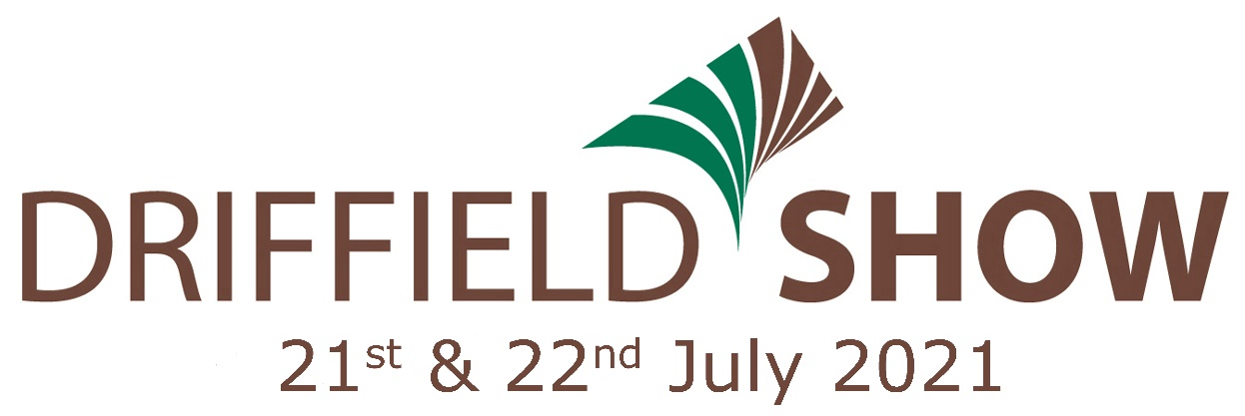

The Driffield Agricultural Society would like to thank the Sponsors of the 2021 Driffield Show for their generous support, especially so
in these challenging times

WOOLLEY & PARKS
ROSE COTTAGE PANTRY SMAILES, GOLDIE GROUP ERYCC WESTLAND HORTICULTURE CROMBIE WILKINSON PETER WARD HOMES
WALLY MAYS ELECTRICAL CONVENIENCE COMPANY CB TRANSPORT
GREAT DRIFFIELD RADIO JACKSON ROBSON LICENCE ACCOUNTANTS W SCRUTONS LTD LIVINGSTONE MOTOR GROUP HYMERS COLLEGE

