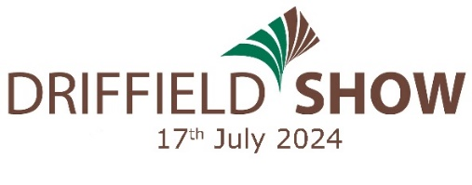

All completed entry forms to:- THE LIVESTOCK SECRETARY, Driffield Show, Driffield Showground, Kelleythorpe, Driffield, YO25 9FB

Or email to: office@driffieldshowground.co.uk In aid of SHEEP & CARCASE SECTION ENTRY FORM
PLEASE WRITE CLEARLY IN BLOCK CAPITALS
OFFICE USE | CLASS NO. | BREED | SHEEP HEALTH SCHEME Y/N | DATE OF BIRTH | ENTRY FEE
Name …………………………………………………………………………………………………………………………..  Address ……………………………………………………………………………………………………………………….  …………………………………………………….. Post Code …………………………………………………………..  Email …………………………………………………………………………………………………………………………..  Telephone No ……………………………………………………………………………………………………………. |  |  |  | FEES
 |  |  |  | Membership @ £50 each
 |  |  |  | Extra Tickets @ £18 each
 |  |  |  | Programme @ £3.50 each
 |  |  |  | TOTAL
Please indicate
number of
pens required
Signed ………………………………………………………………………………………. Date ……………………………………..
Please note only signed entry forms will be accepted.
Payment by DEBIT/CREDIT CARD (unfortunately we are unable to accept American Express)

Card No ………………………………………………………………………………………………………………………

Expiry Date ……………………………………….. Start Date …………………………………………..

Issue No ……………………………….. Security No …………………………………..

ENTRIES CLOSE FIRST POST 17TH JUNE, 2024 – ALL ENTRY FEES MUST ACCOMPANY THIS FORM
NOTE: The certificate of MV/CAE status-accredited flock must be presented to the Sheep Steward before the sheep are unloaded
Entry fees in excess of £20 will receive an additional ticket. Exhibitors will receive 2 admission tickets for each section entered. Extra tickets may be purchased from www.driffieldshowground.co.uk. Please enclosed a stamped addressed envelope if you require confirmation of your entry.
Late entries accepted at the discretion of the Livestock Secretary.
Each exhibitor shall be solely responsible for any consequential or other loss, injury or damage done to or occasioned by, or arising from any animal or article exhibited by them, and for its description given in the catalogue, and shall and indemnify the Secretary and Society Officers and Servants against all legal or other proceedings in regard thereto. Completion of this entry form acknowledges the exhibitors agreement to abide by and accept all terms and conditions of the Driffield Show as laid out in the Show Regulations in the Livestock Schedule.

