Attention School Science Co-ordinators

DRIFFIELD SHOW 17th JULY 2024

Schools’ Green Planet & Gardening Challenge

Sponsored by
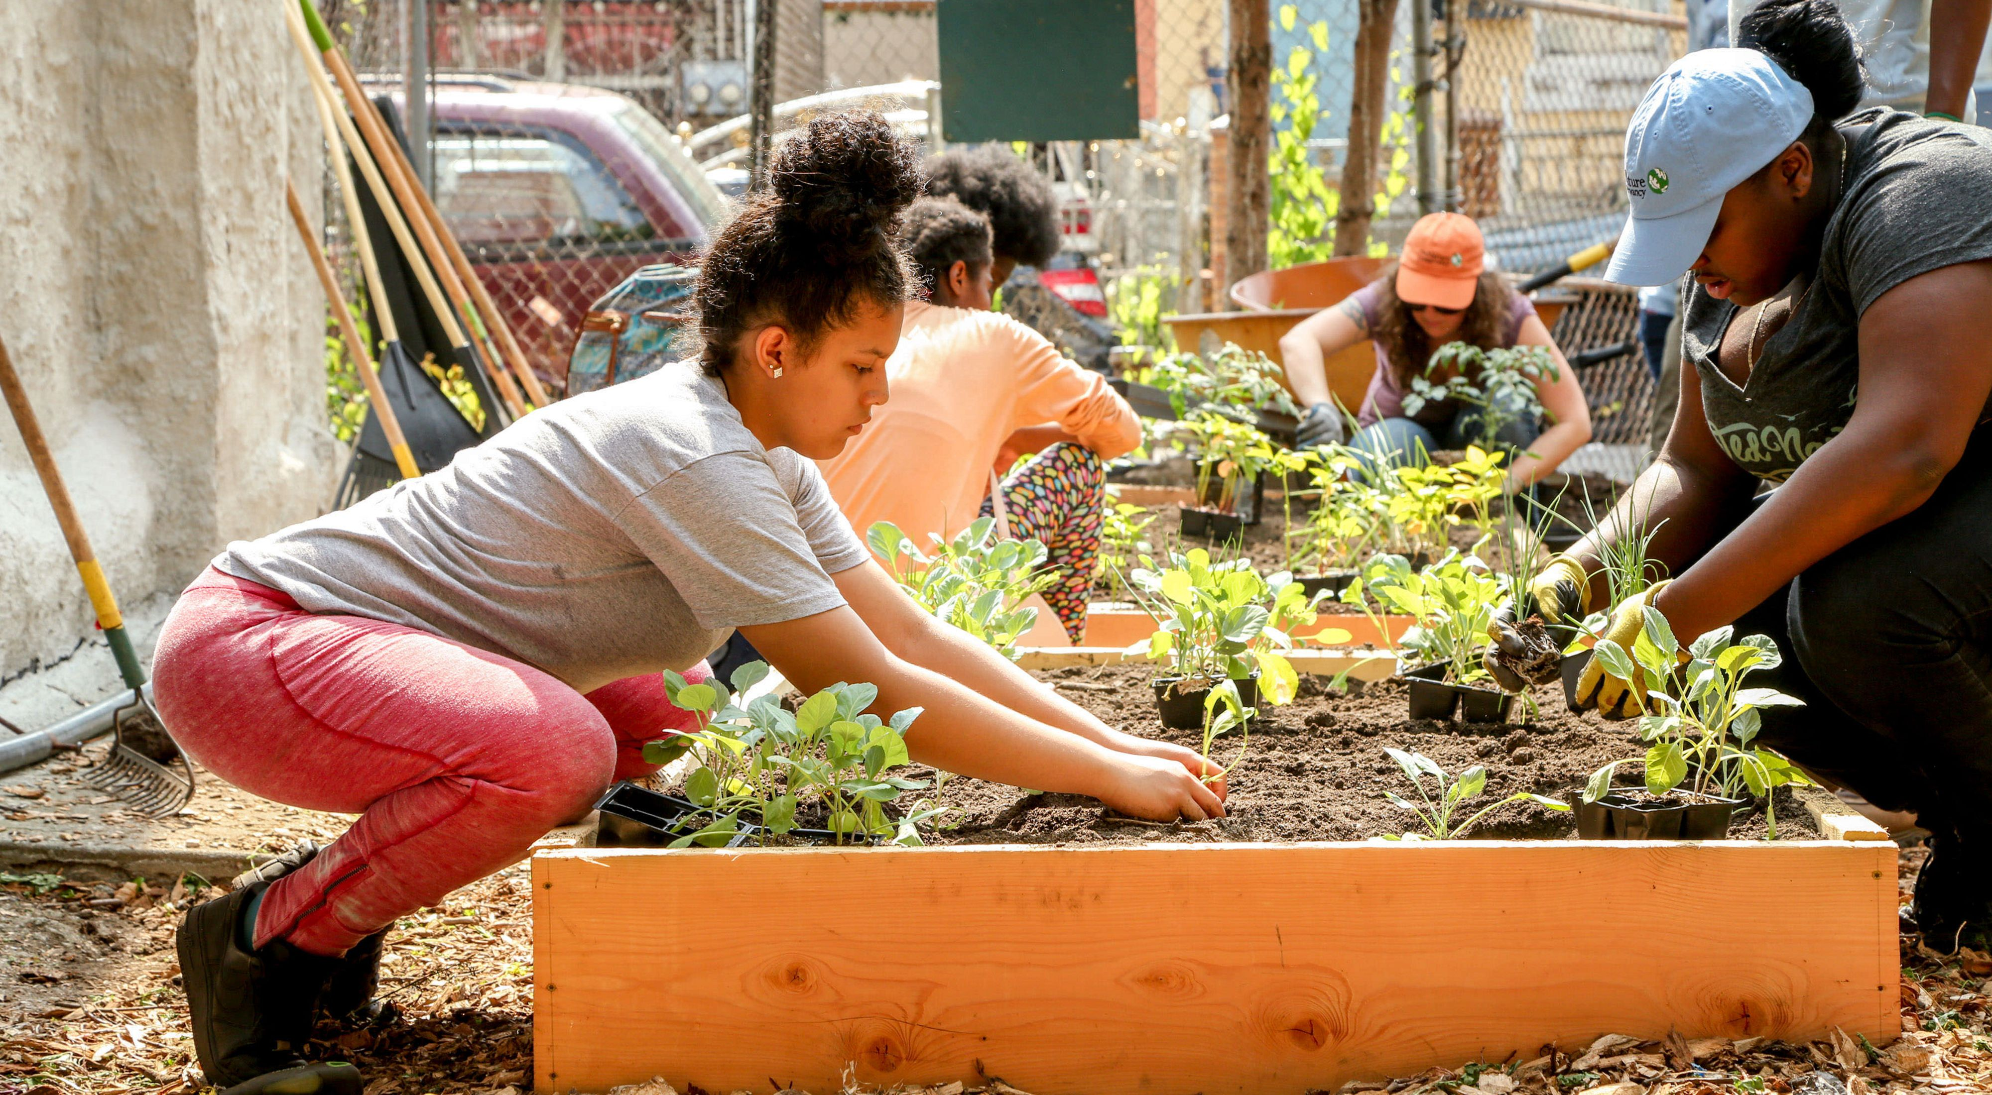
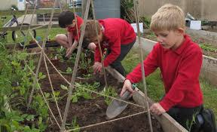

Are you involved in projects for a sustainable future or do you have a garden at your school ?
Would you like a growing project or a ‘Green Planet’ activity for the summer term? Then why not
join with other schools from the area and get involved in the Driffield Show Challenge. Great prizes are to be won and your exhibits will be displayed at the show.
The show is one of the largest one day agricultural shows in the country and is a wonderful educational experience for school children offering the opportunity to view farming, food production and countryside activities.

We challenge your pupils to choose ONE OR MORE of the following :-

CHALLENGE ONE – SCHOOL GARDEN PRODUCE
Ist prize £100, 2nd prize £60, 3rd prize £40
  - Display produce grown at school by the pupils. Products made using items grown in the school garden can also form part of the display.
  - Display a poster (preferably A1 size & PORTRAIT orientation), produced at school by the children, depicting the growing experience. A diary may also be created and displayed.
A space one metre wide will be allocated

CHALLENGE TWO – A GARDEN IN A RECYCLED CONTAINER
Ist prize £100, 2nd prize £60, 3rd prize £40
Design and plant a garden in a recycled container to display at the Show. The garden can contain plants which are either ornamental or edible. A wheelbarrow will be available to transport the garden.

CHALLENGE THREE - GREEN PLANET CHAMPIONS
Ist prize £100, 2nd prize £60, 3rd prize £40
What are you and your school doing to help towards a sustainable and green future? Create a display showing what you have been doing at your school . You might concentrate on recycling, encouraging bees, soil & worms, water security, wild life areas, growing vegetables, composting or many more ideas of your own. A space approximately one metre wide will be allocated.

CHALLENGE FOUR – BEE FRIENDLY POSTER
GOOD END OF TERM FUN PROJECT !!!! (Individual prizes for each winner)
Design a colourful poster on A1 paper to promote how bees help farmers and growers with pollination of crops. As many entries per school as you want.

Sponsors of the competition, Yorkshire Peas, will be providing generous prizes to enable winning schools to purchase items to assist with environmental projects.
Entries can be sent as soon as possible but definitely before 1st July and can be brought to the Horticulture Marquee on the showground on Tuesday 16th July or before 9am on Wednesday 17th July. .

DRIFFIELD SHOW

YOUNG GROWERS’ CHALLENGE
17th July 2024

Sponsored by

ENTRY FORM

School……………………………………………………………………………….

Address ……………………………………………………………………………

…………………………………………………………………………….

……………………………………………………………………………..

Telephone ………………………………………………………………………….

Name of Contact at School …………………………………………………….

Email address ......................................................................................

We would like to enter :-

Challenge One - Garden Produce Display Number of entries ……..

Challenge Two – A Garden in a recycled container Number of entries ………

Challenge Three – Green Planet Champions Number of entries ………

Challenge Four – Bee Friendly Poster Number of entries …………

Please email your entry to mooredgehouse@yahoo.com

Or alternatively mail to :-
Mrs G. Butler, Horticulture Secretary, Driffield Agricultural Society, Moor Edge House, Brandesburton, Driffield, E. Yorkshire, YO25 8LT or
Mrs G. Butler, Horticulture Secretary, Driffield Agricultural Society
The Showground, Kelleythorpe, Driffield, East Yorkshire, YO25 9DN
It would be appreciated if entries could be received before 1st July 2024
The Showground, Kelleythorpe, Driffield, East Yorkshire, YO25 9DN
T: 01377 257494 E: office@driffieldshowground.co.uk www.driffieldshowground.co.uk

